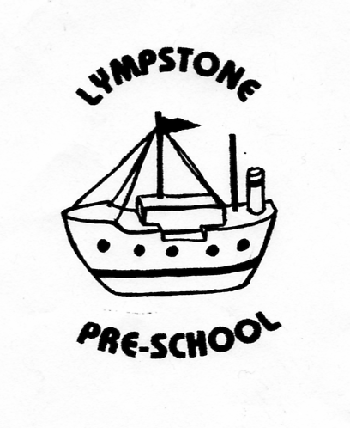

DATA PROTECTION STORAGE/SAFETY PROCEDURES

- LYMPSTONE PRESCHOOL (LPS) WILL ABIDE BY GDPR REGULATIONS AND WILL COLLECT AND STORE INFORMATION IN A SECURE AND CONFIDENTIAL MANNER – SEE PRIVACY NOTICE/DATA PROTECTION & CONFIDENTIALITY POLICY – ALL STAFF WILL BE AWARE OF THIS AND ADHERE TO PROCEDURES WHEN DEALING WITH PERSONAL INFORMATION
- LPS WILL STORE ALL INFORMATION IN A LOCKABLE ROOM WITH ACCESS ONLY PERMITTED BY THOSE WHO HAVE THE RIGHT TO ACCESS INFORMATION, WHERE REQUIRED AND THE INFORMATION IS OF A PERSONAL NATURE IT WILL BE HELD IN A LOCKED FILING SYSTEM.
- INFORMATION FROM PARENTS/CHILDREN/STAFF (DATA SUBJECTS) WILL BE OBTAINED WITH CONSENT AND WILL BE STORED AND SHARED ONLY WITH CONSENT – UNLESS LEGAL/LAWFUL REQUIREMENT OVERRIDES THIS.
- DATA SUBJECTS HAVE THE RIGHT TO REMOVE CONSENT AT ALL TIMES AND CAN BE ASKED FOR INFORMATION TO BE REMOVED/ERASED UNLESS IT IS A LEGAL REQUIREMENT THAT WE KEEP ON FILE (SEE RETENTION OF RECORDS DOCUMENT)
- PERSONAL INFORMATION ON COMPUTER/PHONE/TABLET/ELECTRONIC DEVICE WILL BE PASSWORD OR PIN PROTECTED AND WILL BE KEPT SECURELY ON SITE UNLESS REQUIRED FOR EMERGENCY CONTACT (EG ON OUTINGS)
- ALL INFORMATION WIL BE KEPT UP TO DATE AND WILL ONLY BE COLLECTED AS REQUIRED ON A LAWFUL BASIS BY THE SETTING AND WITH CONSENT
- LPS WILL BE A MEMBER OF ICO AND WILL UPDATE THIS MEMBERSHIP ANNUALLY
- STAFF WILL BE INFORMED OF ALL GDPR REGULATIONS AND WILL SIGN AGREEMENT TO ABIDE BY GDPR REGULATIONS IN RELATION TO ALL DATA PROCESSING
- STAFF WILL BE ASKED FOR CONSENT FOR THEIR PERSONNEL FILES TO HOLD PERSONAL INFORMATION AND WILL BE STORED IN THE SAME SECURE AND CONFIDENTIAL MANNER ABIDING BY RETENTION PROCEDURES AND LEGAL REQUIREMENT
- CHILDREN/STAFF WILL NOT HAVE ACCESS TO ANY UNAUTHORISED INTERNET SITES AND WILL BE MONITORED AS PER THE IT RISK ASSESSMENT/POLICY
- STAFF FILES – STAFF WILL BE ASKED FOR CONSENT TO STORE PERSONAL INFORMATION
- CHILDRENS FILES – EXISTING PARENTS/CARERS WILL BE GIVEN A STATEMENT/ACCESS TO PRIVACY NOTICE AND WILL BE ASKED TO CONTACT PRESCHOOL IF THEY HAVE ANY CONCERNS OR QUERIES – NEW WELCOME PACKS WILL INCLUDE CONSENT TO STORE INFORMATION WITHIN THE CONSENT SECTION
- ADDITIONAL CONSENT WILL BE SOUGHT TO SHARE INFORMATION UNLESS THERE IS SAFEGUARDING/CHILD PROTECTION RISK TO THE CHILD/OTHER PERSON WHICH REQUIRES INFORMATION TO BE SHARED – ALL INFORMATION STORAGE/SHARING WILL BE DONE IN LINE WITH GDPR REGULATIONS

