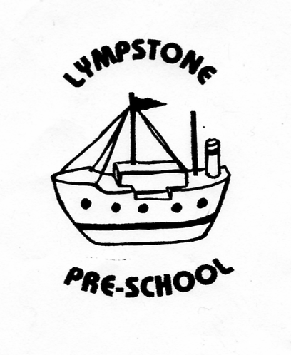

Lympstone Preschool Sun Protection Policy
At Lympstone Preschool we acknowledge the importance of sun protection and want staff and children to enjoy the sun safely. We will work with staff and parents to achieve this through:
EDUCATION:
-Children will share sun-smart stories throughout the summer term.
-Parents and guardians will be sent a letter explaining what we are doing about sun protection and how they can help keep children safe in the sun.
-Staff and children will share stories of how we keep safe in the sun
PROTECTION:
-When the sun is strong we encourage children to sit/play in the shade where it is available.
-The Nature Garden is used daily. Children will apply suncream from their named suncream bottle before entering the area and take water bottles with them. We have certain areas of the nature garden covered by cargo netting to ensure children have access to shade and some protection from the sun when playing there. We also have a shaded tepee when shelter is required.
-If children are playing in the Nature Garden they wear protective hats at all times. Staff are also required to wear sunhats.
-During the warmest summer months sails are attached to the perspex roof in the outside classrooms to provide a cooler playing environment. Children will have access to water play and their water bottles at all times. If the weather is particularly hot staff will rotate the groups of children so they have access to the air conditioned indoor classrooms regularly.
-On signing in at the start of sessions parents are asked to declare if they have applied suncream to their children. If not, parents are asked to apply their own suncream from the suncream box before leaving them at the session.
-Staff will reapply suncream from the children’s own named suncream bottles to all children if required in the afternoon as best practice.
TIME TABLING:
-Children will spend more time playing outdoors in the morning and afternoon and will be encouraged to stay indoors/in shaded areas at the hottest part of the day (approx. 11.45-1.00pm)
CLOTHING:
-Children are required to wear sun hats whenever they are playing outside on sunny days
-If children do not have their own hat, preschool have a supply of suitable hats as spares to ensure all children have hats made available to them.
-Staff have also been asked to wear hats where possible to set a good example to the children.
-Children have been asked to remove hats when back inside the building as it is good manners to do so.
SUNCREAM:
-Parents have been asked to supply named bottles of suncream of SPF 30+ at least, which staff will then use throughout the day where required. Parents have also been asked to provide a new bottle at the beginning of the summer season so that the suncream is in date and is most effective. They have been advised of this procedure and the Sun Protection Policy by letter.

POLICY WAS REVIEWED …………………………………………………………..

SIGNED…………………………………………………………………………………….

