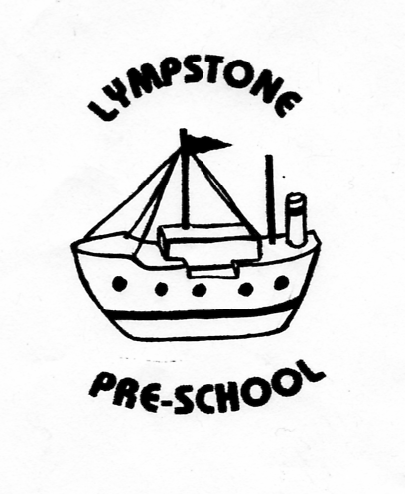

Lympstone Preschool Sun Protection Policy
At Lympstone Preschool we acknowledge the importance of sun protection and want staff and children to enjoy the sun safely. We will work with staff and parents to achieve this through:
EDUCATION:
-Children will share sun-smart stories throughout the summer term.
-Parents and guardians will be sent a letter explaining what we are doing about sun protection and how they can help keep children safe in the sun.
-Staff and children will share stories of how we keep safe in the sun
PROTECTION:
-When the sun is strong we encourage children to sit/play in the shade where it is available.
-We have invested in an electric awning to cover the free flow play area outside to ensure children have protection from the sun when playing.
-The Nature garden is used daily and has a shaded classroom area to provide additional/optional shade cover.
-If children are playing in the Nature Garden they wear protective hats at all times.
-On signing in at the start of sessions parents are asked to declare if they have applied sun-cream to their children and if not are asked to from the sun-cream box before leaving them at the session.
-Staff will reapply sun-cream to all children if required in the afternoon as best practice.
-Cargo netting is available in the Nature Garden area to provide additional temporary shade on very sunny days as required.
TIME TABLING:
-Children will spend more time playing outdoors in the morning and afternoon and will be encouraged to stay indoors/in shaded areas at the hottest part of the day (approx. 11.45-1.00pm)
CLOTHING:
-Children are required to wear sun hats whenever they are playing outside on sunny days
-If children do not have their own hat, preschool have a supply of suitable hats as spares to ensure all children have hats made available to them
-Staff have also been asked to wear hats where possible to set a good example to the children.
-Children have been asked to remove hats when back inside the building as it is good manners to do so.
SUNSCREEN:
-Parents have been asked to supply named bottles of sunscreen of SPF 15+ which staff will then use throughout the day where required. They have been advised of this procedure and the Sun Protection Policy by letter.

POLICY WAS REVIEWED …………………………………………………………..

SIGNED…………………………………………………………………………………….

