Too unwell for Preschool?
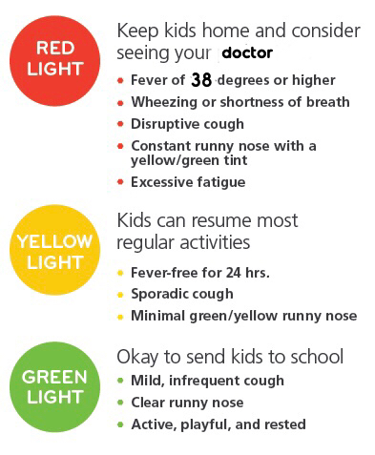

  - OUR PRESCHOOL CHILDREN ARE VERY GOOD AT SHARING…
Please keep them home if they are unwell to help stop the spread of the nasty bugs. If in doubt ring and check! Please remember our 48hr clear rule from the last bout of any illness from stomach bugs…
We will also send your child home from preschool if: they have a temperature or fever, they do not feel well enough to take part in preschool activities, they have been sick/have frequent loose stools or they have any discharge from infected ears/nose/eyes.
Please help us stay healthy at preschool 😷

