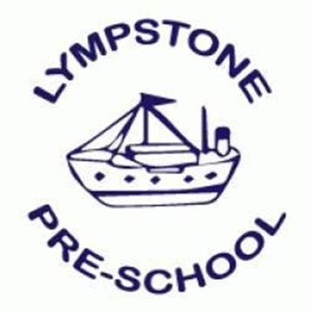
Lympstone Preschool – our Mental Health and Wellbeing Promise (MARCH 2020)

- Lympstone Preschool is committed to promote a healthy and positive environment for our children and families to attend and our team of staff to work within. Within our ethos ‘Play, Learn, Thrive, Grow’ we strive to create a supportive environment which prospers positive Mental Health experiences.

- With this promise in mind we have a designated Mental Health Support member of the management team – Vicki Drinkwater - who has undertaken Mental Health Awareness training for both children and adults, SafeTALK Training (Petes Dragons) and will be undertaking Emergency First Aid for Mental Health when it becomes available in the Summer Term 2020. Vicki Drinkwater will be the point of contact for all Mental Health concerns and disclosures from both staff and children and will liaise closely with the preschool SENDCO and Child Protection Officer, Caroline Armstrong, to work out strategies and make relevant referrals to outside professionals (Nursery Plus/EdPsych/EYC/CAHMS) as and when necessary.

- As per all aspects of the preschool any information gathering, holding and sharing will follow strict guidelines of data protection, confidentiality and GDPR regulations and will be treated in a sensitive manner and will follow the setting safeguarding policy and procedure.

- Within the working environment Lympstone Preschool are committed to supporting the health and wellbeing of our team and with our Mental Health promise will also strive to promote and support a work/life balance. If staff require additional support we will undertake a risk assessment with regular reviews, will create a wellbeing action plan and will strive to make reasonable adaptations to work to support the staff member to access work whilst maintaining a competent and able position within the team. Preschool will also promise to support where possible with reasonable adaptations any sickness leave relating to Mental Health and a return to work which is safe and secure for the individual whilst maintaining a strong, healthy and competent team for the children in our care.

- As part of our promise and commitment to our positive Mental Health strategy in the setting we have regular sessions of Mindfulness and Meditation run by a local trained consultant for staff and children to attend. These sessions will be extended on a subsidised basis to our families on a weekend over some sessions during the year.

