Lympstone Preschool

Weekly Round-up
Half Term holiday club 24th – 28th October 2022
Last Day of Autumn Term 16th December
Christmas Holiday Club 19th-23rd December19th

Important dates
and reminders

(Autumn Term 1 week 1)
Welcome to all of our new families and welcome back to our returning children. We hope you all had an amazing summer. What a start to the new term we have had, our new starters have all settled in so well and our older children have been amazing kind, nurturing and welcoming to them all.
This week we have welcomed a new member to the team, Terri, who is going to be taking over the role of Sendco. She has many years of experience in this area and is going to be a fantastic addition to our already amazing team. She will be working with all of children providing intervention as and when it is needed.
This week has been very busy, we have been doing a lot of experimenting with colour mixing with paints and coloured water to make potions. A group of children went on a foraging expedition on Thursday and came back laden with apples and blackberries which were then turned into a crumble. Earlier in the week we all put on our wellies and waterproofs and enjoyed some time in the nature garden getting very wet and muddy in the puddles. We will be outdoors in all weathers so your support with bringing in named wellies and overalls is essential. Thank you to everyone who has already done so.
Today after the sad news of the Queen passing away we have been sharing a book about her life and reign and talking about our feelings using some emotion books to spark the conversations. We have had lots of conversation around long and happy lives. Lots of the children wanted to make sparkly crowns so the preschool looks like a glitter factory explosion!

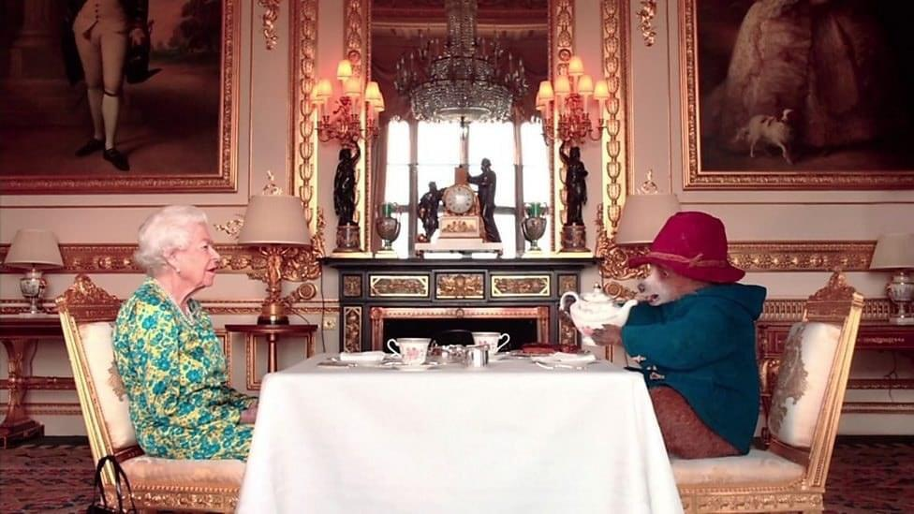

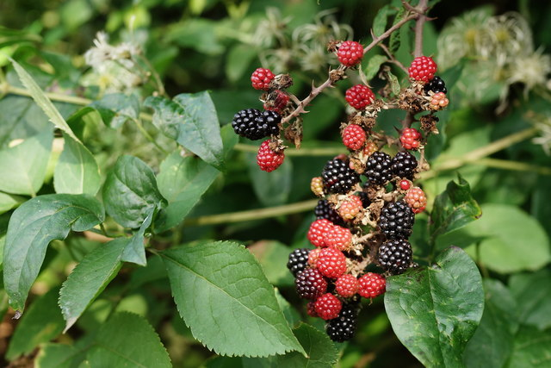

Staff star of the week
Terri
Snack Donations
This week we would like Kiwis, bananas, peppers And fruit loaf

