Lympstone Preschool

Weekly Round-up
Monday 19th September - CLOSED
Half term Holiday Club 24th – 28th October
Cake Sale 4th November

Important dates
and reminders

(Autumn Term 1 week 2)
This week the children have been settling into their new routines, we are really proud of how our new starters have taken everything in their stride and how our older children have taken them under their wings.
With the weather turning more Autumnal we have been donning our wellies and overalls and heading to the nature garden to enjoy lots of muddy play, thank you to everyone who has brought in named wellies and overalls in a drawstring bag. If you require a drawstring bag we are selling them at the price of £3. If you would like to purchase one please speak to Kate or Caroline. As well as the nature garden we have been out on the field playing with the sports equipment and then down the conker tree to collect the shiny brown treasures. Inside we have been exploring moon sand and using shaving foam as cement for bricks.
We have welcomed all our school children back to breakfast and afterschool club, we have enjoyed hearing stories of what they have been up to over the summer. We have changed how they access their breakfast and snack to a much more independent self service approach, which all of the children seem to be embracing.
All of the children have doing a lot of talking about the sad news of The Queen passing and talking about their feelings, we will be continuing with this over the coming days and weeks as we know that Monday will be an emotional day for lots of you. We are closed on Monday as a mark of respect so will see you all Tuesday.

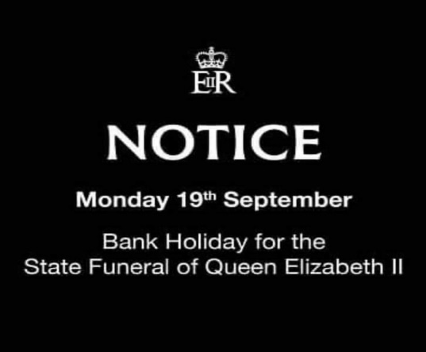
Snack Donations
This week we would like Apples, Pears, plum for snack donation please

Staff star of the week
Jan

