Lympstone Preschool

Weekly Round-up
Half term 24th-28th October 2022
AGM 1st November
Cake Sale 4th November

Important dates
and reminders

(Autumn Term 1 week 7)
The children have been busy little learners throughout this week as we come to end of term, they have enjoyed some wonderful activities both indoors and outdoors- especially the muddy puddles splashing in the nature garden.
We have enjoyed lots of different craft activities including pumpkin painting using a variety of fruits and vegetables, looking at the marks we have made, the children really enjoyed exploring the spiders and spiderwebs we then recreated our own spider webs.
This week our baking activities including making gingerbread mummies and spooky cupcakes, which we down a treat. We have been using the nails and hammers to hammer into the pumpkins using lots of different skills.
We will be holding our termly cake sale on Friday 4th November at 3pm so will be calling all bakers to help to make some cakes, if you’re not a baker you can help by buying some of our yummy offerings.

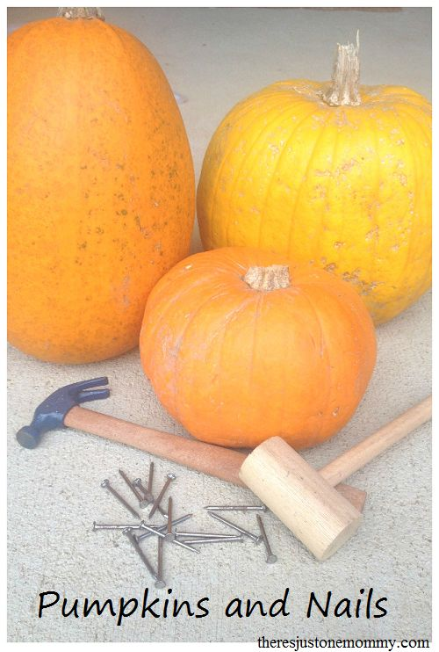
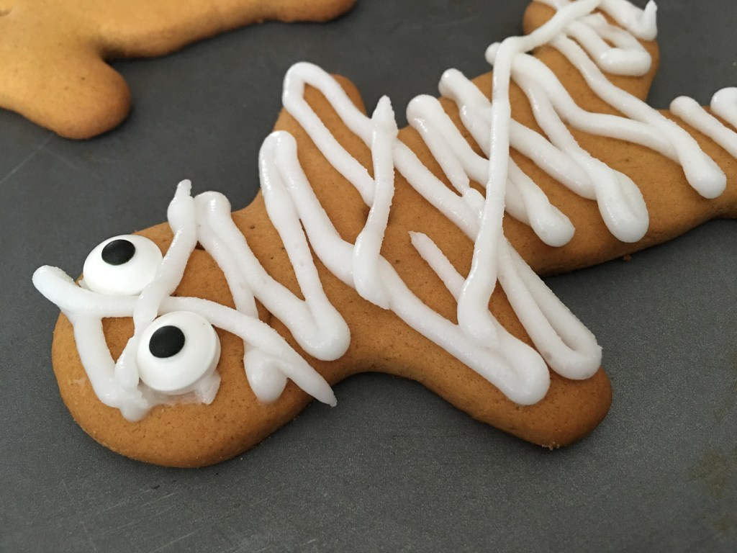

Terri
Snack Donations
Thank you for your continued support with snack donations. this week we would like Breadsticks, ricecakes and fruit

Staff star of the week

