Lympstone Preschool

Weekly Round-up (Autumn Term week 12)
This week we have been preparing for Christmas, we have been doing lots Christmas singing and showed everyone at the Christmas festivities how we knew all the songs and actions.
We have been enjoying the different material and resources from the junk modelling, especially helping to make a post box and Christmas decorates for the Christmas tree.
The children have shown a lot of interest in telephones and keyboards and walkie talkies playing alongside each other.
We’ve enjoyed the nature garden this week making potions and blowing our own bubbles using the wands.
We have enjoyed cooking making gingerbread people and festive biscuits, using our skills of rolling mixing and weighing out the ingredients.
Thank you to everyone who came to our Christmas event on Thursday, I think everyone who came would agree it was a lovely evening, with the bonus of raising over £100!
Last day of Autumn Term 16th December
Christmas Holiday Club 19th-22nd December
First day of Spring Term 4th January 2023

Important dates
and reminders

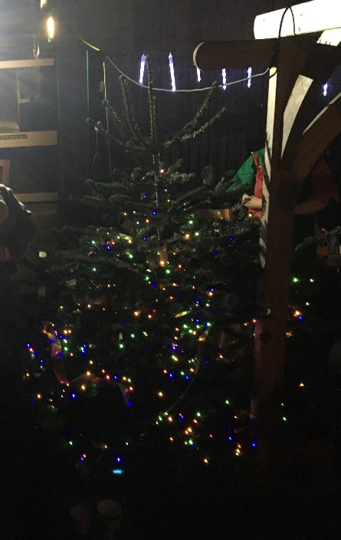
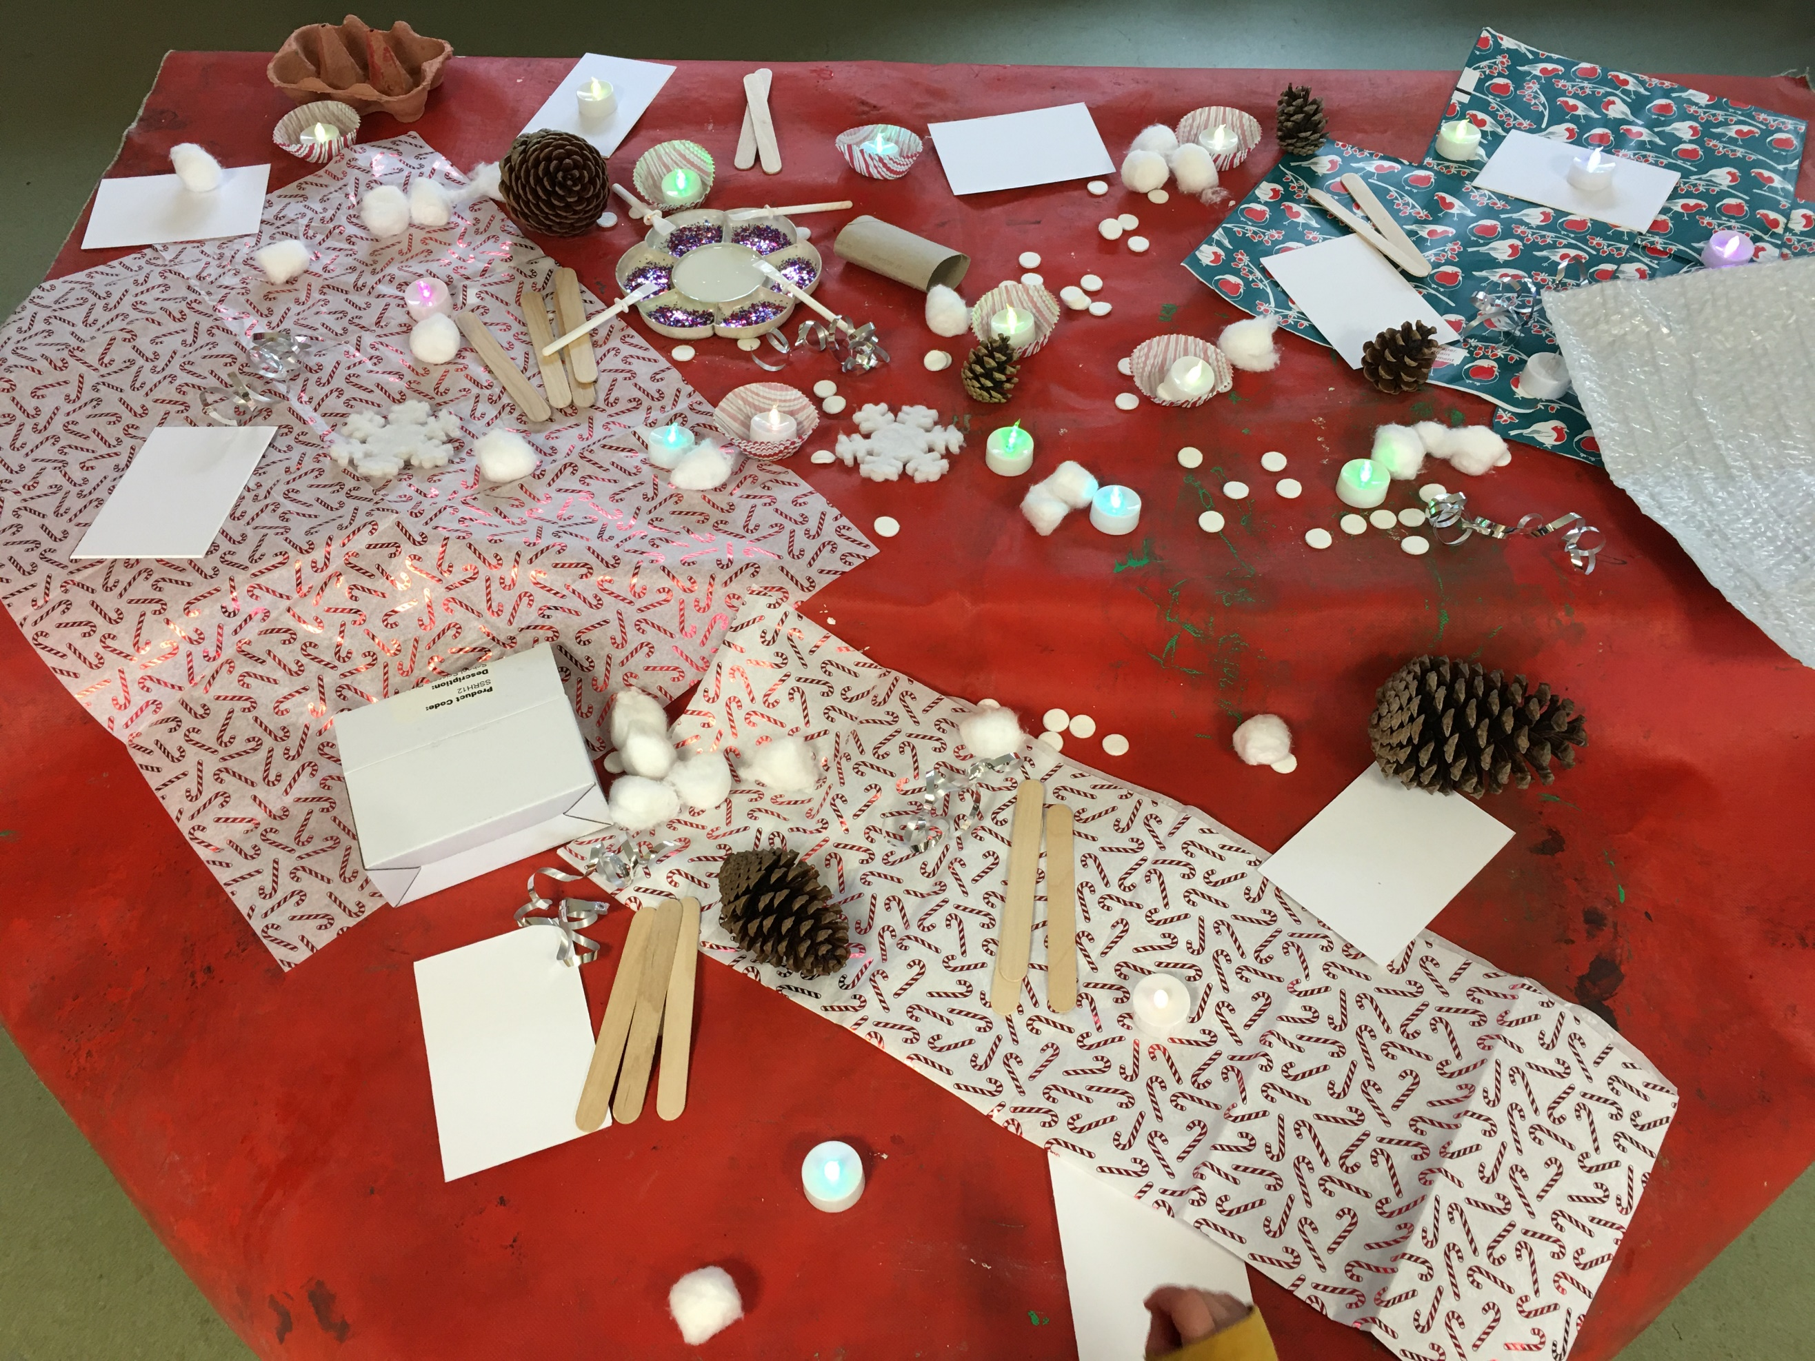
Kasia and Chloe P

Snack Donations
Thank you for your continued support with snack donations. this week we would like Crackers and fruit
fruit loaf, banna
Staff star of the week

