Lympstone Preschool

Weekly Round-up
Half term 29th May-2nd June
Sports Day 21st June 10:30am
End of term party leavers party 19th July 2:00pm

Important dates
and reminders

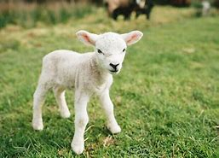
(Summer Term 1 week 2)
The children have been busy little learners throughout this week we have been busy exploring the nature garden, we made mud potions and mud cakes, we have been enjoying mark making painting using different colors and mud mixed together.
We have been to see the lambs on are walk and we enjoyed singing baa baa black sheep. We then enjoyed coloring making pictures of the lambs and spring flowers.
This week during cooking we made chocolate or jam swirls, we have been using our skills of rolling mixing and weighing out the ingredients using the scales.
The breakfast and afterschool children have enjoyed making loom bands and playing football.
We are now taking bookings for May half term, please get in touch if you would like to book.

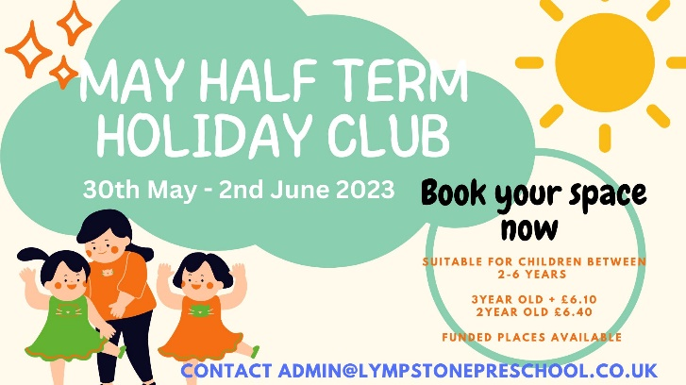

Staff star of the week
Everyone
Snack Donations
Thank you for your continued support with snack donations. this week we would like Breadsticks, ricecakes and fruit.

