Lympstone Preschool

Weekly Round-up
Half term 29th May-2nd June
Sports Day 21st June 10:30am
End of term party leavers party 19th July 2:00pm

Important dates
and reminders

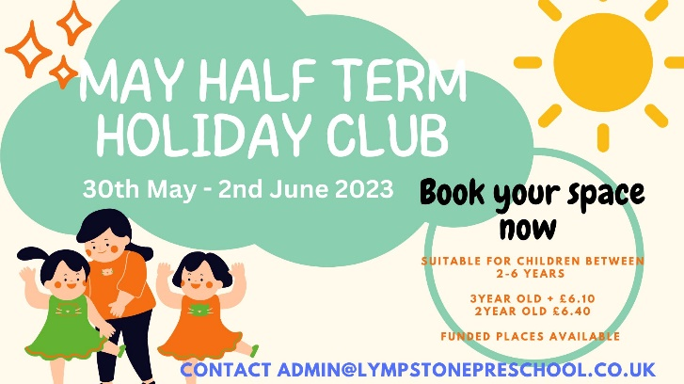
(Summer Term 1 week 3)
The children have really enjoyed exploring the nature garden we have been making lots of marks in different materials we have used a range of materials including flour, mud, crazy foam and paint. We have been enjoying the musical instruments singing our favorite songs.
We have been to the beach with the dinosaurs and made them a little den with all the wood and shells we could find on are walk down and along the beach wall. We enjoyed going to see the train go past waving.
This week during cooking we made cupcakes and adding the union flags to the top in preparation of the king’s coronation.
The breakfast and afterschool children have enjoyed coloring and making lots of lovely creations with the junk modelling. The have really enjoyed playing uno and other card games with the preschool children.
We are now taking bookings for May half term, please get in touch if you would like to book.

Staff star of the week
Snack Donations
Thank you for your continued support with snack donations. this week we would like fruit and vegetables.
Chloe and Terri

