Lympstone Preschool

Weekly Round-up
Half term 29th May-2nd June
Sports Day 21st June 10:30am
End of term party leavers party 19th July 2:00pm

Important dates
and reminders

(Summer Term 1 week 4)
The children have really enjoyed being outside in the nature garden we made a den, and we made crowns using grass and flowers and sang songs around the pit. Whilst in the nature garden we made clay models and added fresh flowers we had found on are adventures.
We have been to see the lambs and went for an adventure to the waterfall, we enjoyed smelling the fresh garlic and looking for the different birds in the trees singing.
This week during cooking we made smoothies we discussed which fruits we liked and where they came from in the world, we then liked cutting up the fruit and adding it to the blender and smooth the fruits and vegetables.
The breakfast and afterschool children have enjoyed being outside playing football and using the rackets and balls. They have especially enjoyed the dolls and clothes role playing in the home area.
We have updated our amazon wish list; we would like to say thank you for those who have been generous in purchasing the items we have added to our wish list.
To view our Wishlist click this link - Amazon.co.uk

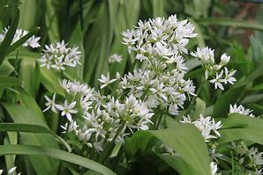
Staff star of the week
Snack Donations
Thank you for your continued support with snack donations. this week we would like Crackers and Healthy cereal.
Tasha

