Lympstone Preschool

Weekly Round-up
Half term 29th May-2nd June
Sports Day 21st June 10:30am
End of term party leavers party 19th July 2:00pm

Important dates
and reminders

(Summer Term 1 week 5)
The children have had a lovely week in the sunshine, we have been enjoying the nature garden and the field, we have been cooling off in the water play activities and ice cubes.
We have been to the brook to play pooh sticks and we took the soft play equipment out on the field and enjoyed a game of frisbee, we have enjoyed the park.
This week during cooking we made mud pies outdoors in the nature garden and we liked digging in the soil and then using the hose to add to the texture. We then found a selection of loose parts to add to the pies and made a birthday.
The breakfast and afterschool children have enjoyed reading stories to the younger children and they have really enjoyed coloring and making lots of creations with the junk modelling.
Katie Hancock is taking on the Commando Training Challenge this year on the 20 July. With all donations going towards the RMA please use the link bellow or scan the QR code in the picture to donate. Any amount is welcomed as it supports the whole of the RM as a collective.
https://rmatrmc.enthuse.com/pf/katie-salway

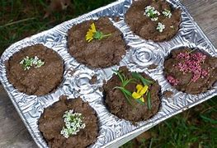
Staff star of the week
Snack Donations
Thank you for your continued support with snack donations. this week we would like Crackers and Healthy cereal.
Katherine

