Lympstone Preschool

Weekly Round-up
End of term party leavers party 19th July 2:00pm
Holiday club starts 20th July.
Garden Work 14th-31st August.
First day of autumn term Wednesday 6th September.

Important dates
and reminders

(Summer Term 1 week 10)
The children have had a lovely week, they enjoyed their sports day despite the weather everyone embraced the rain, and it was a fun morning thank you to everyone who attended.
We have been enjoying the nature garden looking for bugs and taking our clipboards and magnifying glasses to search for the little hidden bugs.
This week we made a big den and liked climbing through the tunnel to explore the sensory lights and different sensory objects, we also enjoyed lots of messy activities including soapy sand and flour play.
The breakfast and afterschool children have enjoyed making boats using the large bricks and setting sail around the room, they have been very creative with the Lego building bridges and castles.
During the summer holidays we are planning to do some work to our outside areas. If you have a skill or trade that you think could help and you are willing to give some time between 14th and 31st August, please get in touch.
If you are stilling looking for summer holiday club, we still have our bookings open if you want to book to avoid disappointment.
Here is the link for the lottery to be in for a chance of winning a Nintendo switch. https://www.yourschoollottery.co.uk/lottery/school/lympstone-preschool
We have updated our Amazon wish list; we would like to say thank you for those who have been generous in purchasing the items we have added to our wish list and how helpful it for us to receive such lovely gifts. To view our Wishlist click this link - Amazon.co.uk

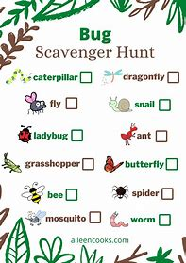

Snack Donations
Thank you for your continued support with snack donations. this week we would like crackers and fruit please.
Staff star of the week
Jan

