Lympstone Preschool

Weekly Round-up
Photographer is attending on 13th June
Sports Day 21st June 10:30am
End of term party leavers party 19th July 2:00pm

Important dates
and reminders

(Summer Term 1 week 8)
The children have had a fun and exciting week, we have been very keen gardeners we have been planting plants with Kate, and speaking about how important it is to keep them hydrated just like ourselves.
We have been out on the field practicing for our sports day, we have been running races and practicing our throwing to make sure we have a good aim to splat Tasha.
This week we have had enjoyed building with the Lego and playing with the dolls helping to dress and change them and role playing in the home area, we have enjoyed looking at the different leaflets and discussing what we can see, following the map with our fingers and discussing about the places we have visited, Paignton zoo was a firm favorite.
The breakfast and afterschool children have enjoyed being out on the field playing sports and helping the younger children to play basketball taking turns and showing them how aim and throw.
We have updated our amazon wish list; we would like to say thank you for those who have been generous in purchasing the items we have added to our wish list.
To view our Wishlist click this link - Amazon.co.uk

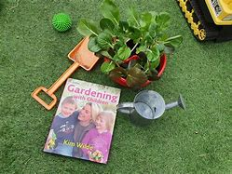
Staff star of the week
Kyra
Snack Donations
Thank you for your continued support with snack donations. this week we would like breadsticks and fruit please.

