Lympstone Preschool

Weekly Round-up
Sports Day 21st June 10:30am
End of term party leavers party 19th July 2:00pm

Important dates
and reminders

(Summer Term 1 week 9)
The children have had a lovely week we have been trying to keep cool, by having the water sprinkles out to play in and lots of different water-based activities, especially the lemons and water were a big hit.
We have been watching the school children compete in their sports day, we enjoyed cheering for them and watching them collecting their medals.
This week we have had enjoyed the playdough, making lots of cakes for our friends who have recently celebrated their birthdays, we made pizza this week we spoke about the different ingredients we could use and our favorite toppings.
The breakfast and afterschool children have enjoyed playing card games such as uno and have really been interested in making and creating their own booklets.
We have updated our amazon wish list; we would like to say thank you for those who have been generous in purchasing the items we have added to our wish list.
To view our Wishlist click this link - Amazon.co.uk

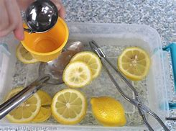
Staff star of the week
Laura W
Snack Donations
Thank you for your continued support with snack donations. this week we would like crackers and fruit please.

