Lympstone Preschool

Weekly Round-up
End of term party leavers party 19th July 2:00pm
Holiday club starts 20th July.
Garden Work 14th-31st August.
First day of autumn term Wednesday 6th September.

Important dates
and reminders

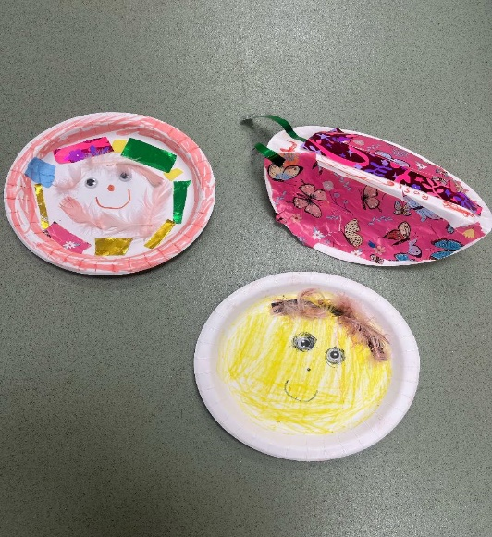
(Summer Term 1 week 12)
The children have had a fun week, we have been enjoying the foot spa, soaking our feet in the water, and making lots of bubbles. Whilst we enjoyed the foot spa, we have also been showing lots of interest in making of potions mixing colors and adding the glitter to see what different colors we can make.
We have been creative and been making paper plate birds, painting our favorite colors and patterns, and adding the feathers and eyes. We have enjoyed watching the bubble tube spotting the different colored fish floating around the tube.
This week we have really enjoyed doing lots of action songs, learning the different dances, our firm favorite was the wiggly woo dance.
The breakfast and afterschool children have enjoyed exploring the clay making lots of different models and creations, the especially enjoyed the paper plates using a variety of different materials including junk modelling, sticking, and making their own creations.
During the summer holidays we are planning to do some work to our outside areas. If you have a skill or trade that you think could help and you are willing to give some time between 14th and 31st August, please get in touch.
Here is the link for the lottery to be in for a chance of winning a Nintendo switch. https://www.yourschoollottery.co.uk/lottery/school/lympstone-preschool
We have updated our Amazon wish list; we would like to say thank you for those who have been generous in purchasing the items we have added to our wish list and how helpful it for us to receive such lovely gifts. To view our Wishlist click this link - Amazon.co.uk

Snack Donations
Thank you for your continued support with snack donations. this week we would like healthy cereal and fruit please.
Staff star of the week

