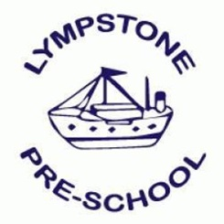
Lottery and Fundraising Policy

For the purposes of general fund raising, Lympstone preschool registered charity 1038447) has applied, and been granted a small lotteries licence. This licence (number SL0313) has been issued by East Devon district Council. Subject to its rules and regulations, the lottery shall not have an income of over £250,000 per annum and reports shall be made to the council monthly.
There shall be weekly lottery draw, falling on the Saturday of each week. We use a 3rd party company called Your School lottery to fulfil this activity. Prize funds will vary dependant on the number of participants.
Should Lympstone preschool wish to add any additional draws and/or fundraising events, they will be in line with all regulations and will also be included in any monthly reports sent to East Devon District Council.
The overseeing of any draws and fundraising events will be undertaken by manager, Kate Grabke, Business Assistant Manager Katherine Billing, and/or Lympstone Preschool Committee.
Records will be kept in line with retention plans for the setting and will be declared through usual income channels to the setting account, and independent auditor each financial year.

This policy has been agreed by Lympstone Preschool Committee Date 30/06/2022

