Lympstone Preschool

Weekly Round-up

(Autumn Term 1 week 5)
23rd October -30th October Half term
Holiday club is still open for bookings please book in as soon as possible to secure a place.
1st December Christmas light switch on at preschool.

Important dates
and reminders
This week has been an exciting week, watching the change in weather, enjoying the sunshine, and exploring the autumn sensory activities.
We have been creative making our autumn displays including collecting different fallen leaves and exploring the pumpkins and squash we discussed the colors and textures; we liked taking the inside of a pumpkin out for the sensory experience.
We have been out exploring we went to the beach and took our shoes off to feel the different textures between our toes, we liked looking for the crabs under the seaweed and in the little pools, we then collected sea glass.
The children have shown a keen interest in the cars, we have been making ramps using a variety of objects to see how fast we can make our cars go, we have been discussing the distances and we liked making bumpy roads for the cars to go across. We have enjoyed the sensory experiences this week especially the sand digging and using different tools to look for hidden objects, splashing in the water and using the paint to make marks on different textures.
This week at toddler group, the children enjoyed using the animals to make mark in the paint and outside they enjoyed the sensory experience of the crazy foam.
The breakfast and afterschool children have enjoyed being outside using the hammers and screw drivers making lots of different objects, they have enjoyed making their own stickers, coloring, and cutting them out.
a place.

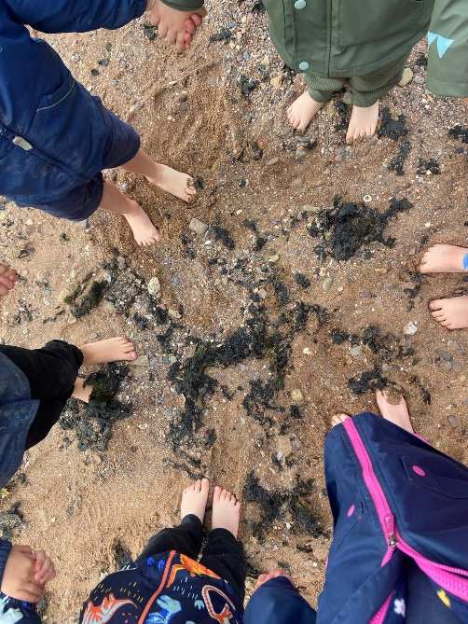

Snack Donations
Thank you for your continued support with snack donations. this week we would like Heatlthy cereal and fruit.

