Lympstone Preschool

Weekly Round-up

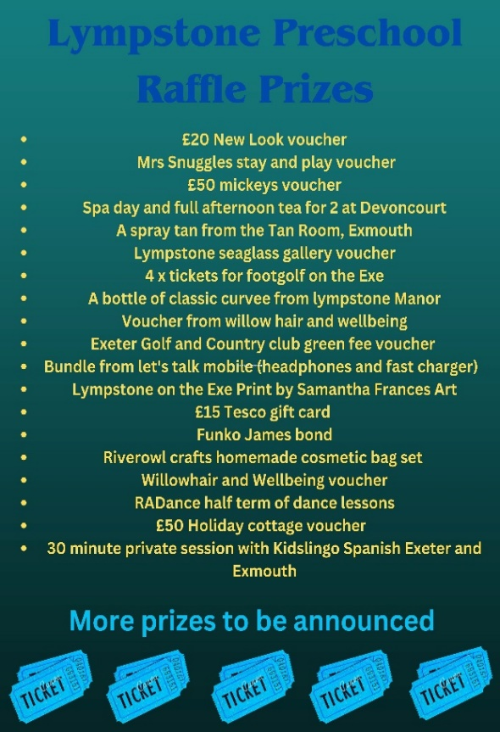
(Autumn Term 1 week 7)
Snack Donations
Thank you for your continued support with snack donations. if your child/children are booked in to attend holiday club please remember to bring a fruit snack for the morning.

This week we have had a lovely week; we have been enjoying lots of different sensory activities we especially liked the pumpkins and colored rice. Using a variety of tools to scoop the rice transporting to different sized and shaped pots.
We have had lots of fun in role play areas, we liked the dressing up trying on different hats and looking at ourselves in the reflection of the mirrors.
We made colorful cakes collecting the ingredients and using the scales to weight out the ingredients we spoke about the different numbers on the scales and the difference between wet and dry textures.
The children have been very interested in the technology we have had walkie talkies and pretend telephones, role playing different scenarios. We have made an office area including keyboards and little note pads, the children have loved using there writing skills to make marks and posting letters to each other.
This week at toddler group, the children played in the covered outside area in the sand and really enjoyed exploring the colored rice and pumpkins.
The breakfast and afterschool children have been making the longest loom bands trying to see how far they can reach across the room, they have enjoyed making cakes and one day they made ghost marshmallow biscuits, what a treat!!
We are still making the rooms feel even more cozy, which can be a challenge in such a clinical building. We are looking for donations of soft furnishings and lamps to help with the ambience. If you have anything you no longer need and would like to donate, please send a picture to the preschool WhatsApp. Thank you for those who have donated already.

a place.

23rd October -30th October Half term.
1st December Christmas light switch on at preschool. More info to follow on timings and how to buy tickets.
Raffle to be drawn 1st December.

Important dates
and reminders

