Lympstone Preschool

Weekly Round-up

(Autumn Term 2 week 1)
This week has been very busy, we have enjoyed lots of Halloween activities, carving pumpkins and we had an experiment with the pumpkin we made a volcano and watched it fizz over the top. We enjoyed making spiders using the playdough.
We have enjoyed the new furniture and making our preschool very cozy, we have especially liked the dressing up trying on different items of clothes and the different style hats.
We been making waffles with our new waffle machine discussing the ingredients and how to make them healthy using a variety of fruits. We enjoyed making pumpkin biscuits, talking about the numbers, weight and using the scales we talked about the ingredients we needed to make biscuits.
This week at toddler group, we had the pumpkins and they enjoyed painting and washing the pumpkins in the water, we also had the story sack of room on the broom, we liked recreating the story.
We have been enjoying the autumn weather, we have been on a nature walk discussing the different colored leaves that have fallen and the collection different size leaves, we went to the beach and liked looking out to sea discussing the different birds we could see. We enjoyed looking at our shadows on the field.
The breakfast and afterschool children have enjoyed making suncatchers with different Halloween scenes, we made Halloween cards to take home. We discussed fireworks and the children wanted to make firework pictures and discussed the different events of which they are attending this weekend. They enjoyed making paper chains and woodwork, using the tools, and discussing what they would like to make over the next couple weeks including a bird box.

a place.

1st December Christmas light switch on at preschool. More info to follow on timings and how to buy tickets.
Raffle to be drawn 1st December.
Children in need 17th November Please feel free to wear your Pyjamas.

Important dates
and reminders
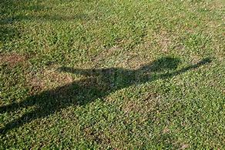
Snack Donations
Thank you for your continued support with snack donations. this week we would like Crackers and Fruit.

