Lympstone Preschool

Weekly Round-up

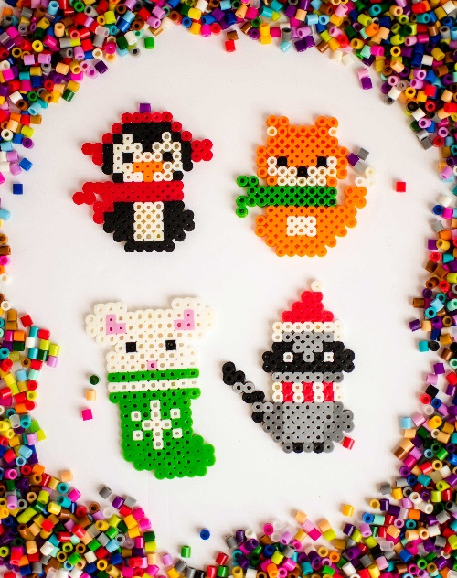
(Autumn Term 2 week 5)
Snack Donations
Thank you for your continued support with snack donations. this week we would like Fruit loaf and fruit please.

1st December Christmas light switch on at preschool, to start at 4:30
Check our Facebook to see if you have won any prizes.
Term ends 19th December; we have a few remaining spaces for holiday club if you would like to book, please email the office.

Important dates
and reminders
This week has been an exciting week, we have been preparing for our annual Christmas light switch on, we have been practicing our songs and actions ready for the evening.
We have been enjoying the fresh outdoors we watched our amazing garden being finished and we are very excited to go out to explore, we were excited to see the snow falling and we were hoping and talking if we have enough snow what kind of snowman or women they wanted to build. We made our own snow using corn flour and conditioner.
The children have been enjoying the Christmas craft, making cards for friends and family and we have enjoyed posting, we made lots of paper chains and we made salt dough ornaments for the Christmas tree.
We have been enjoying singing, especially number songs they have shown a keen interest in 5 little men in a flying saucer and 1,2,3,4,5 once I caught a fish alive showing reptation in number sequences.
The breakfast and afterschool children have enjoyed making Christmas Hama beads for the tree and they have been enjoying playing the orchards games between themselves, they enjoyed playing Jenga and keeping score who has won each round. We made tutu using the netting and we have also enjoyed playing Limbo.
This week has been a week of saying goodbye and good luck to 2 of our staff members, Chloe is off to have her baby which we are very excited and we can’t wait to hear her lovely news, we are also saying good luck and see you soon to Kyra, who is off on her travels to see the world we wish them both the best of luck and we will miss them! But they’re both going to return.

a place.

