Lympstone Preschool

Weekly Round-up
Half term next week we have holiday club for those who have booked.
We return to preschool on Monday 19th February.

Important dates
and reminders

(Spring Term week 6)
This week we have had a lovely week; we have been enjoying lots of different sensory activities we especially liked the colored rice. Using a variety of tools to scoop the rice transporting to different sized and shaped pots.
We have had lots of fun in role play areas, we liked the dressing up trying on different hats and looking at ourselves in the reflection of the mirrors.
We made banana muffins and we have been busy making heart shortbread we collected the ingredients and liked using the scales to weight out the ingredients, we spoke about the different numbers on the scales and the difference between wet and dry textures.
This week we have enjoyed playing in the park and on the zip line, we went for a walk to the beach one day and collected sea glass, we spotted a crab moving shells and the different kind of birds.
The breakfast and afterschool children have been enjoying making hear sized biscuits and they have been enjoying the role play area, making their own shops and making different models out of the playdough, the children enjoyed making clay models of themselves.
We need your help, we are making the rooms feel even more cozy, which can be a challenge in such a clinical building. We are looking for donations of soft furnishings and lamps to help with the ambience. If you have anything you no longer need and would like to donate, for example wooden bowls, China tea sets, old set of scales photo frames, old bangles, or bracelets. please send a picture to the preschool WhatsApp. Thank you for those who have donated already.

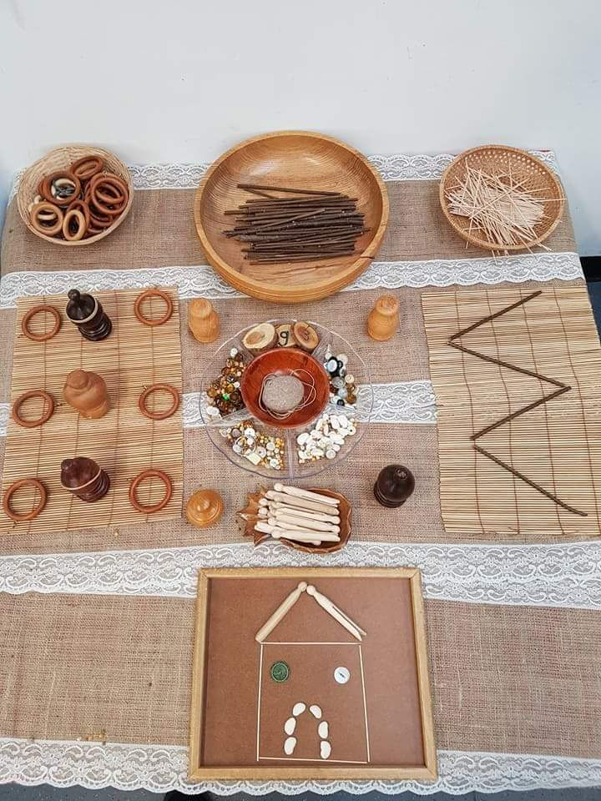

Snack Donations
Thank you for your continued support with snack donations. if your child/children are booked in to attend holiday club please remember to bring a fruit snack for the morning.

