Lympstone Preschool

Weekly Round-up
Holiday Club is open for Easter holidays we are open 2nd-5th April. We are very full and a few remaining spaces available please contact the office if you would like to book.
Preschool is closed 8th-12th April for easter holidays.
Important dates
and reminders

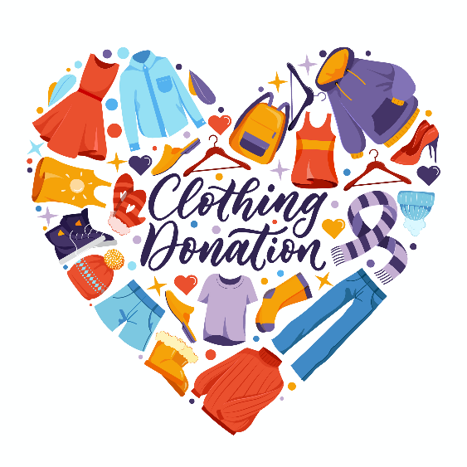
(Spring Term week 10)
This week we’ve had a fun week, we enjoyed going to the park and going for a walk to the harbour, we enjoyed collecting shells and stones from our adventure. We have liked seeing all the spring flowers popping up over the village.
The children have been showing a keen interest in the new cars we have had kindly been donated, we have been using the big paper and pens to draw our road, we have been collecting and making ramps using the wooden pipes for our cars to race down the tubes.
We made Holly a birthday cake and we sang her happy birthday, whilst making the cakes we collected the ingredients and using the scales to weight out the ingredients and cracking the eggs, we spoke about the different numbers on the scales and the difference between wet and dry textures.
This week we have had lots of visits from animals we had the birds of prey visit our preschool on Tuesday we were lucky enough to hold 3 different owls and Chloe told us all about the owls. Tasha brought her bunny rabbit to preschool on Thursday we liked holding the bunny and stroking it, we spoke about the easter bunny at easter.
We have enjoyed reading lots of books this week, our firm favourites were 100 dogs and were going on a bear hunt.
We have been enjoying learning the phonic song silly soup, mixing our soup in a bowl with different objects beginning with the phonic sounds.
The breakfast and afterschool children have been enjoying making flower bunting and making paper frogs cutting and sticking, they have also enjoyed doing spring wordsearch.
Please can you read the email regarding suncream, we don’t charge consumables but we rely heavily on donations.

We would greatly appreciate any clothes donations of sock as we are very low if your child has borrowed a pair of preschool socks, please could these be returned thank you for your continued support.
Snack Donations
Thank you for your continued support with snack donations. this week we would like Crackers AND maltloaf please.

