
Children’s sickness and health Policy
Lympstone Preschool are committed to promoting the health and well-being of all children in our care. We take proactive measures to prevent the spread of illness and infection and ensure that any child who becomes unwell at nursery is treated with sensitivity, dignity, and care.

This policy outlines procedures for managing illness in children attending the nursery and aims to:
- Prevent the spread of infectious diseases.
- Ensure a safe and healthy environment for children, staff, and families.
- Clarify the exclusion periods for common childhood illnesses.
- Establish clear communication expectations with parents/carers

General Guidelines
- If a child becomes unwell while at preschool they will (within the confines of our setting) be kept separate from other children and made comfortable whilst their parent/carer is contacted to arrange collection.

- Children requiring medication to be administered while in Preschool will need to complete a consent form. For more information, please refer to our Administration of medicine policy.

- All staff will be trained in paediatric first aid, and this will be refreshed every 3 years in line with legislation guidelines.

- The Preschool is not permitted to admit any child who appears to be suffering from an infectious or contagious illness. While we follow UK Health Security Agency (UKHSA) guidance, we reserve the right to refuse admission if a child’s condition could impact the well-being of others.

- First aid equipment is kept clean, replenished, and replaced as necessary. Sterile items will be kept sealed in their packages until needed. First aid boxes can be found in each of the Preschool rooms and in the staff kitchen

- Good hygiene practice will be always maintained. In addition to regular daily cleaning of the Preschool, staff will perform termly deep cleans (+ if we have a high case of illness)

Parent/Carer Responsibilities
- Provide up-to-date emergency contact details of a minimum of 2 emergency contacts.
- Inform the Preschool of any illness, absences, or changes to your child’s health.
- Keep children at home for the full exclusion period when unwell (see illness chart below).
- Not bring children into the Preschool if they are unwell, especially if they have been given Calpol or similar medication before arrival, as it may mask symptoms of contagious illness. Any child that has been given such medication before attending preschool will not be admitted until any effects of the medication have worn off (this is 4 hours after initial dose).
- Cuts or open sores, whether on adults or children, will be covered with a hypo allergenic plaster or dressing.

Medical Emergencies
If a child becomes seriously ill or injured:

- Staff will call an ambulance.
- Parents/carers will be contacted immediately.
- A senior member of staff will accompany the child to hospital if needed, along with relevant medical documentation and medication.

High Temperatures
- A fever is classified as a temperature over 38°C (100.4°F) in children under 5.
Procedure:
- Take the child’s temperature with a thermometer.
- Record the reading and inform parents.
- Remove excess clothing and keep the child hydrated.
- Monitor temperature regularly.
- If temperature remains above 38°C, parents must collect their child.
- Calpol may be administered in emergency situations, but prior consent will be sort after.

Febrile Convulsions, Anaphylaxis, and Seizures
- Call 999 immediately.
- Administer emergency medication (e.g., Epipen) if prescribed and authorised.
- Contact emergency contact
- Follow medical emergency guidelines

Sickness and Diarrhoea
Exclusion period is 48 hours after the last episode, not from the onset. This applies to all adults on the site too, to minimize the potential spread of illness and infection.

Broken Bones
If a child has sustained any broken bones, we have a 7-day exclusion period, this allows the child to rest their injury, the Preschool to inform relevant organisation and prepare a risk assessment for the child should you wish your child to attend with a broken bone. After this 7-day period has elapsed management and parents/carers will agree on a gradual reintroduction to Preschool, best suited to the child’s needs.

Hand, foot and mouth
Hand, foot and mouth is a highly contagious infection, Lympstone Preschool reserves the right to operate an exclusion period of until the blisters have scabbed If we deem necessary to contain the risk of the infection spreading. Parents will be informed via email on Learning Journals when this is implemented and the Duration of the exclusion being in place.

Respiratory infection, including Flu & Covid 19

Children with mild symptoms such as a runny nose, sore throat, or slight cough, who are otherwise well can continue to attend our setting.

All children and young people with respiratory symptoms will be encouraged to cover their mouth and nose with a disposable tissue when coughing and/or sneezing and to wash their hands after using or disposing of tissues.

Infectious illness exclusion periods

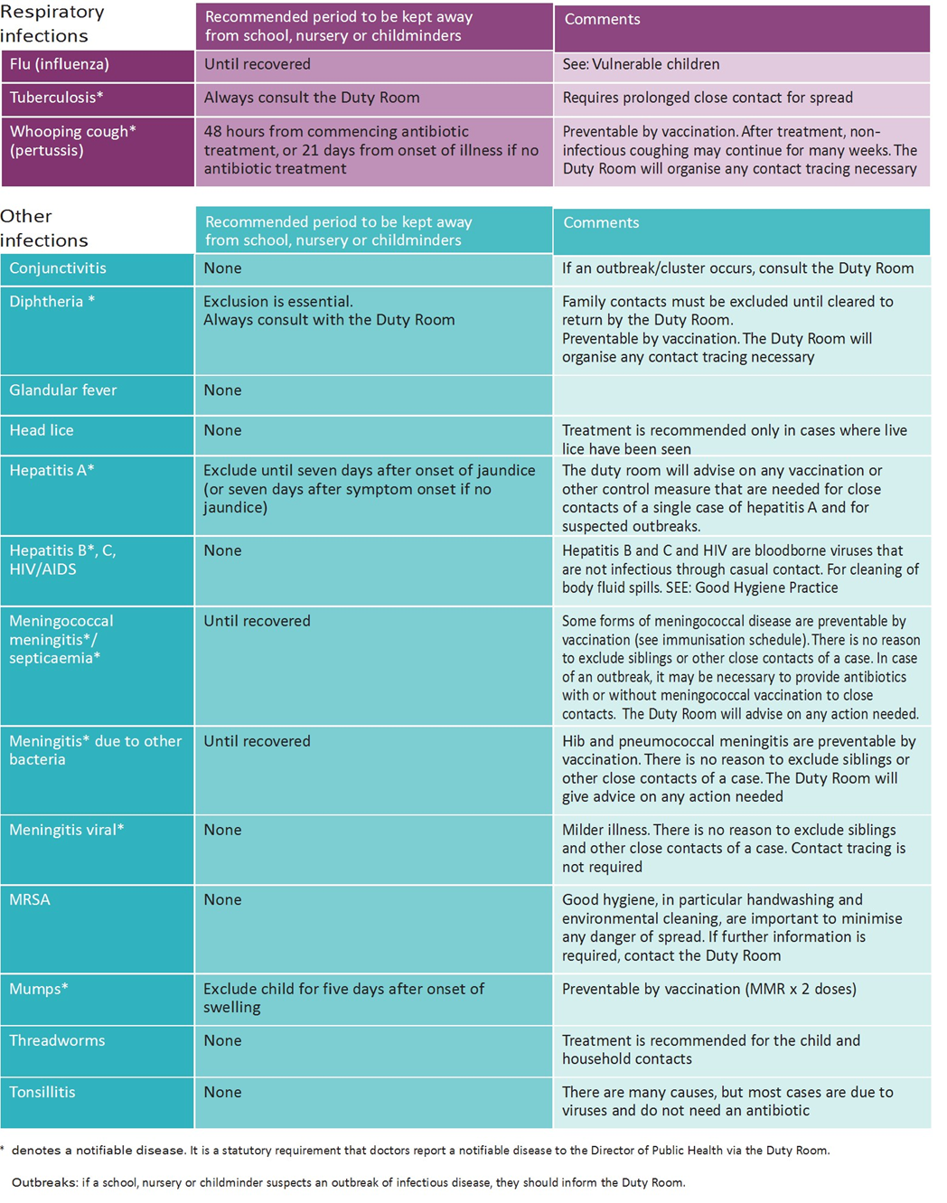
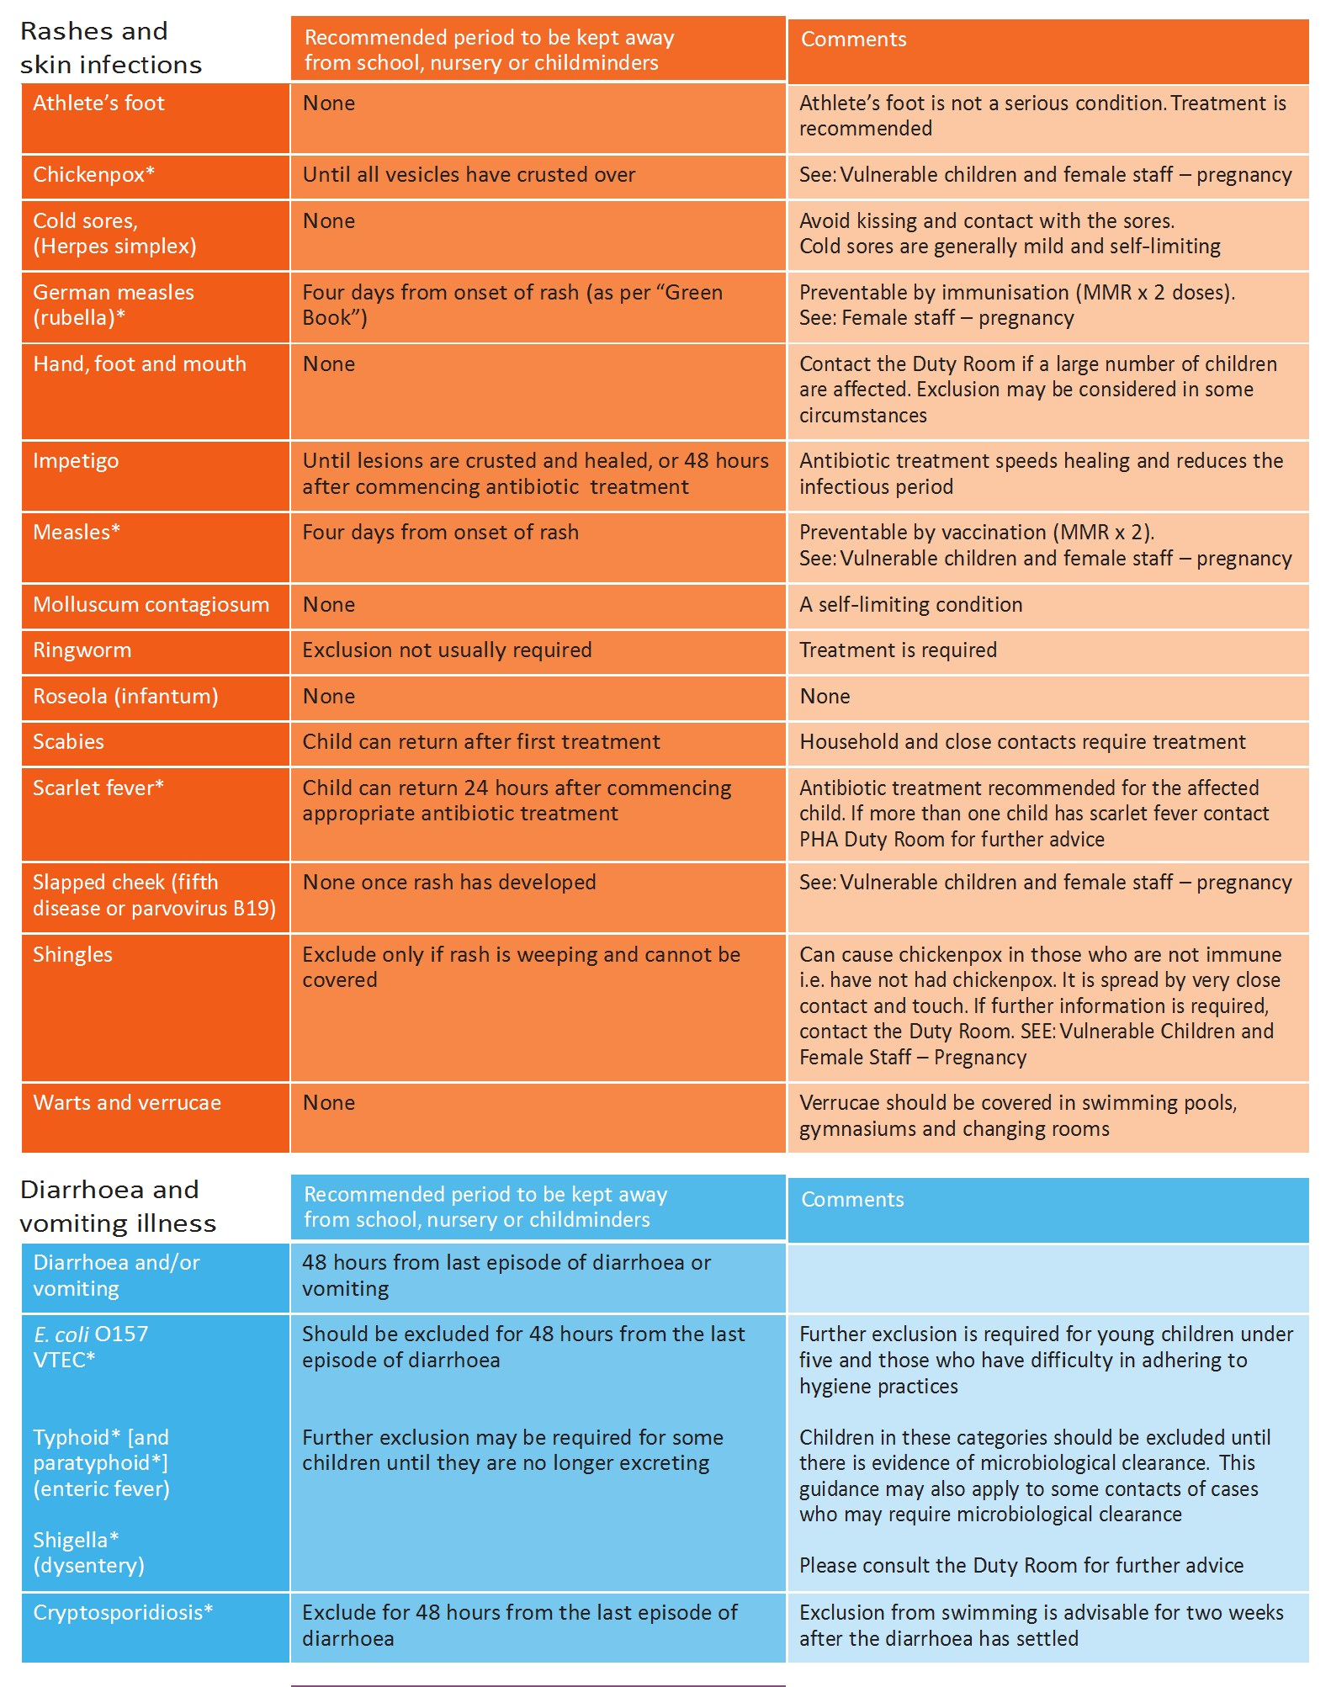

Pandemic / Epidemic
In the case of the pandemic/ epidemic the Preschool will follow the Emergency procedures detailed in the Emergency procedures policy
The Preschool will contact The UK Health Security Agency with any notifiable diseases in accordance with the information found at Health protection in children and young people settings, including education - GOV.UK (www.gov.uk) The Preschool will inform OFSTED and the local authority if a child is known to be suffering from a notifiable disease and act accordingly to any advice which is given. Guidelines for infectious periods and essential required absences from preschool in relation to illness and infectious diseases will be always adhered to and shared with parents to ensure there is limited opportunity for these to spread.

Prescribed medication (Including Antibiotics)
If the child is on prescribed medication the following procedures will be followed:

Antibiotics - A child can return to preschool 24 hours after their first dose of antibiotics. This is to ensure there are no reactions, or side effects and allows time for the antibiotics to start working

- If possible, the child's parents will administer medicine. If not, then medication must be stored in the original container and clearly labelled with child's name, dosage and any instructions for staff to follow.
- Information will be obtained from the parent, giving clear instructions about the dosage, administration of the medication and permission for a member of staff to follow the instructions.
- All medications will be kept in a high cupboard in the kitchen not accessible by children. Staff medications will be logged separately and stored separate to the children’s medication and out of reach of children. Any prescribed medication will be stored in the same manner.
- A medication folder will be stored alongside the medications and available to log in: the name of child receiving medication; times that the medication should be administered; date and time when medication is administered, together with the signature of the person who has administered each dose, their witness to the administration and finally the parent or carer’s signature.

Regarding the administration of life saving medication such as insulin/adrenalin injections or the use of nebulisers, the position will be clarified by reference to the pre-school's insurance company. (In the case of pre-schools insured with Royal & SunAlliance, this will be through the Insurance section at Pre-school Learning Alliance National Centre). If specialist knowledge is required, staff involved in administering medication will receive training from a qualified health professional. All staff will be trained in EpiPen administration within their first aid training which will be refreshed every 3 years in line with legislation guidelines.

Vulnerable children
Some medical conditions make children vulnerable to infections that would rarely be serious in most children, these include those being treated for leukaemia or other cancers, on high doses of steroids and with conditions that seriously reduce immunity. Lympstone Preschool should be made aware of such children. These children are particularly vulnerable to chickenpox, measles and parvovirus B19 and, if exposed to either of these, the parent/carer will be informed promptly and further medical advice sought. Some vulnerable children may need further precautions to be taken, which should be discussed with the parent or carer in conjunction with their medical team and the Preschool.

This Policy has been agreed by Lympstone Preschool Committee. Date 24/08/2023

This policy was updated and agreed by Lympstone Preschool Committee Date: 14/10/2024

This policy was updated and agreed by Lympstone Preschool committee Date 16/12/2024
The policy was amended and agreed by Lympstone Preschool Committee Date 27/08/2025

