
Lympstone Preschool

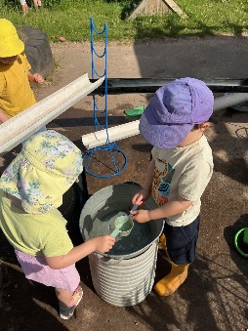
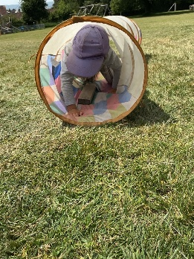

Monthly Round-up (June Summer Term)
Resources Donations
Instead of snack donation this term we are asking for resources please:
we would Love:
- FELT TIP PENS
- Food flouring essences (vanilla, orange, lemon, pepermint)
- Water colour paints
- pasta for sensory play
- Peel & stick foam shapes
- Shaving foam
- Senstivie conditioner
- Corn flour
- COLOURED PENCILS
- Plain flour for playdough
- A4 Printer paper
- A4 Coloured card
- A4 coloured sugar paper
Thank you so much

To view our Wishlist click this link - Amazon.co.uk

21st July (Our Sports day/Graduation/summer fundraiser) Please message our whatsapp to let us know if you are attending.

21st July BAKE SALE
Important dates
and Information
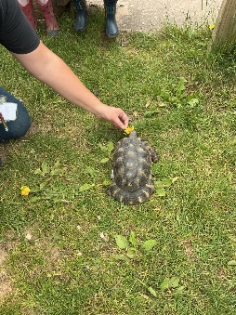
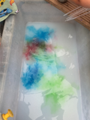
Buzard Room
We have been having a wonderful time practising for Sports Day. The children have all been trying their very best, and it has been lovely to see their confidence and enthusiasm grow as they take part in all the activities.

This month, we also enjoyed making refreshing lemon and mint tea, along with some delicious biscuits. A special highlight was when Tash brought her tortoise, Frank, to preschool. The children loved holding him, learning about him, and feeding him dandelions.

The children have also been visiting their new schools in preparation for starting in September. They have really enjoyed their visits and have been excited to explore their new classrooms, meet their teachers, and begin talking about their next adventure.

Rainbow Room
We have had a wonderful month in Rainbow Room, enjoying lots of exciting activities together. The children have especially loved our baking sessions, where we made delicious biscuits and our own bread. They also had great fun using play dough to create their own pretend biscuits, decorating them beautifully with fresh flowers.

We have been working hard practising for Sports Day and have really enjoyed running around and taking part in all the different activities. It has been fantastic to see everyone’s enthusiasm and growing confidence.

As always, we have loved getting messy while exploring our exciting tuff trays and spending time discovering nature in our garden. It has been another fun-filled month of learning, playing, and making wonderful memories together!

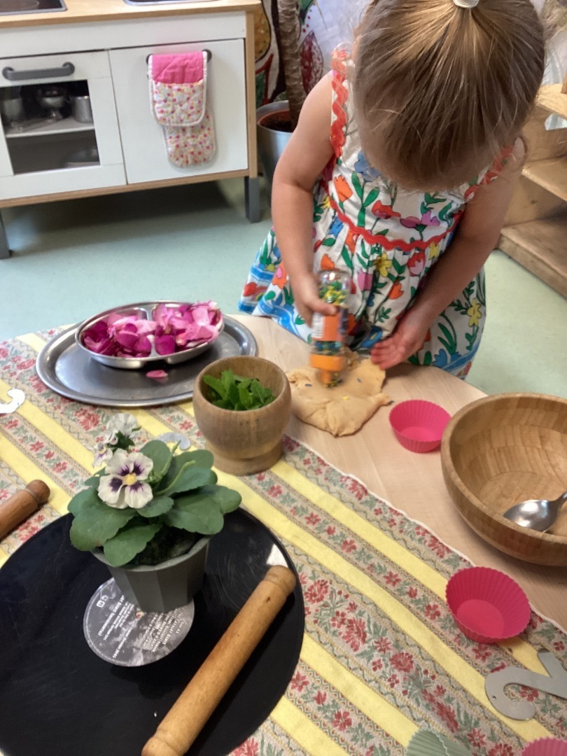

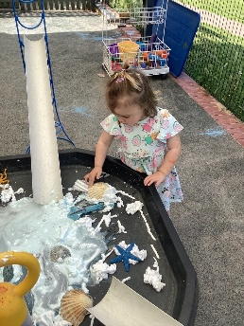
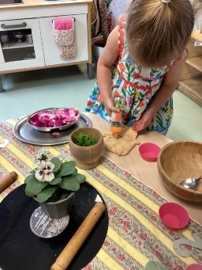
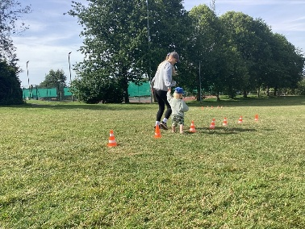
Have a wonderful Weekend. See you next week.

